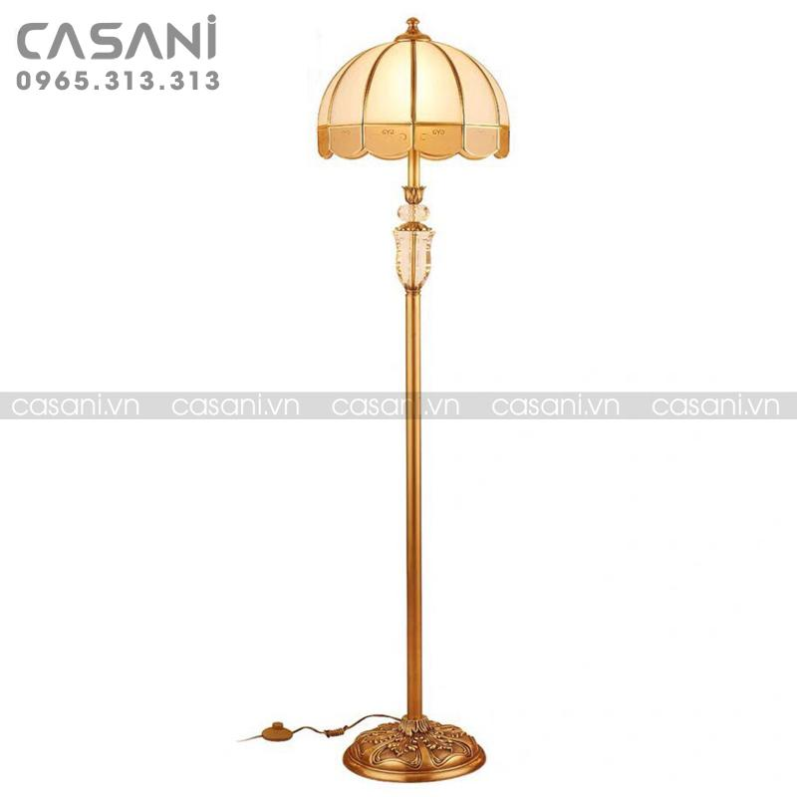

$224.35

- Product name: Decorative floor lamp

- Product code: DDC-2094

- Material: body made of pure copper

- Design: modern

- Size: Height 1m60, lampshade 40cm wide

- Bulb type: LED or incandescent (can be easily purchased on the market)

- Status: In stock

- Warranty: 12 months

- Application: living room decoration, bedroom, interior decoration,...